Assignment 2- Case Study

Stage 3 Lab Activities

SmartCare Domain Modelling
AI OFF -> AI ON -> COMPARE -> VERIFY | 1 hour

A - Requirements Review
Highlight nouns, verbs and business rules in SmartCare v0.2
Nouns: Patient, Practitioner, Appointment, Clinic, Name, Database, Cancellation, Status, Availability.
Highlighted verbs: manage, provide, book, cancel, check, support, store, produce
Business rule:
- The system should prevent duplicate appointment bookings.
- Appointment status should be consistent.
- Practitioner availability should be visible.
- The system should support appointment cancellation.
- The first version should remain simple and manageable.

B - Candidate Classes
Record candidate concepts, supporting requirements, state and behaviour.
- Patient

Supporting requirement: The system needs to support patient management.

State:
- patientID
- name
- contactDetails

Behaviour:
- requestAppointment()
- cancelAppointment()

- Parctitioner

Supporting requirement: The system needs practitioner management and must improve visibility of practitioner availability.

State:
- practitionerID
- name
- availability
Behaviour:
- provideAvailability()
- manageAppointments()

- Appointment

State:
- appointmentID
- dateTime
- status

Behaviour:
- createBooking()
- checkStatus()
- cancel()

C - CRC Cards
Create CRC cards for Patient, Practitioner and Appointment.
- CRC Card 1- patient

Class: Patient | Responsibilities | Collaborators
 | Store patient information
 | Request/book an appointment | Appointment
 | Cancel an appointment | Appointment

- CRC Card – Practitioner
Class: Practitioner | Responsibilities | Collaborators
 | Store practitioner information
 | Provide availability | Appointment
 | Manage/attend appointment | Appointment

- CRC Card – Appointment
Class: Appointment | Responsibilities | Collaborators
 | Create/store appointment booking
 | Check appointment status | Patient, Practitioner
 | Support cancellation | Patient, Practitioner

D - UML Model
Draw classes, attributes, operations, associations and multiplicities.

E - AI Design Review
Ask AI to suggest classes and relationships using only confirmed requirements; require supporting requirement IDs.

F - Compare and Decide

AI suggestion | Decision | Reason | Requirement
Patient Manager | Rejected | Patient is already a domain class; separate manger is unnecessary. | The system must support patient management, and first version should be simple and manageable rather than a complex hospital information system.
Schedule Engine | Modified | Availability is required, but a complex engine is not required. | The system should provide visibility of practitioner availability and program should be simple and manageable.
Notification Manager | Rejected | No confirmed notification requirement | No requirement
Patient-Appointment association | Accepted | Patient needs appointment management | The system must support patient management and the system must support appointment management .

G - Python Skeletons
Create simple Patient, Practitioner and Appointment class skeletons.
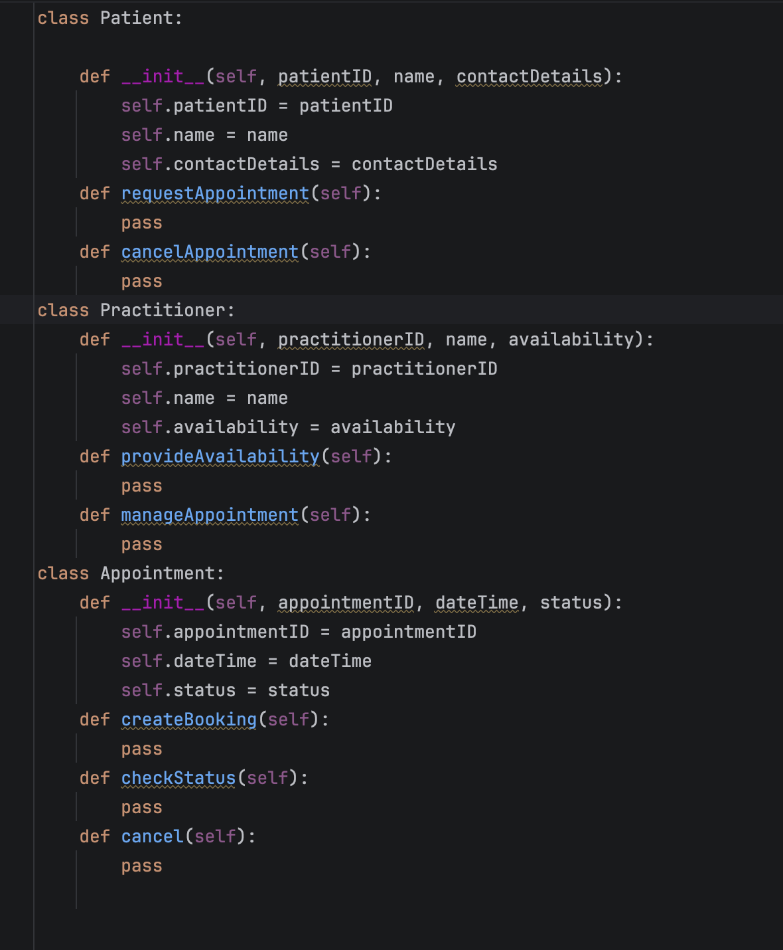

H - Consistency Check
Check model-code consistency; do not implement full behaviour yet.
UML element | Python element | Consistent?
Patient | Patient class | Yes
Practitioner | Practitioner class | Yes
Appointment | Appointment class | Yes
Patient attributes | Patient attributes | Yes
Practitioner attributes | Practitioner attributes | Yes
Appointment attributes | Appointment attributes | Yes
Patient operations | Patient methods | Yes
Practitioner operations | Practitioner methods | Yes
Appointment operations | Appointment methods | Yes
Patient- Appointment association | UML only at this stage
Practitioner- Appointment association | UML only at this stage

Reflection
What modelling decision was hardest?
The hardest modelling decision was deciding whether concepts such as Clinic, Cancellation, database and Schedule Engine should become classes. It was necessary to distinguish between domain concepts and technical implementation concepts. I decided to keep Patient, Practitioner and Appointment as the main domain classes because they directly support the confirmation requirements. Cancellation was treated as an operation, while database and Schedule Engine were not included because they would add unnecessary technical complexity to the first version.
Where did AI over-design?
AI over-designed the system by suggesting classes such as PatientManager, PractitonerManager, AppointmentManager, NotificationManager and ScheduleEngine. These classes were not directly supported by the confirmed requirements. For example, NotificationManager was not required because the case study did not specify a notification requirement. ScheduleEngine was also more complex then necessary because the requirement only identified the need for practitioner availability.
What evidence supported your final choices?
My final modelling choices were supported by the SmartCare case study and the identified requirements. The case study explicitly states that the system should initially support patient, practitioner and appointment management. It also identifies duplicate bookings, inconsistent appointment status, limited practitioner availability and manual cancellation as current problems. Finally, the case study states that the organization does not want a complex hospital information system and that the first version should be manageable. These requirements supported keeping the model simple with Patient, Practitioner and Appointment as the main domain classes.

